**CẤU HÌNH DATAGUARD DB ORACLE**

Thông tin cấu hình

**- Primary server: db1**

+ sid: TRANGAN

DB_UNIQUE_NAME=PRIMARY

[root@db1 ~]# df -h

Filesystem Size Used Avail Use% Mounted on

/dev/sda3 34G 4.8G 27G 16% /

tmpfs 16G 72K 16G 1% /dev/shm

/dev/sda1 485M 39M 421M 9% /boot

/dev/sdb1 30G 6.2G 22G 22% /u01

/dev/sdb2 20G 172M 19G 1% /data

/dev/sdc1 9.9G 151M 9.3G 2% /redo01

/dev/sdc2 9.9G 151M 9.3G 2% /redo02

/dev/sdc3 30G 172M 28G 1% /archivelog

**- Standby server: db2**

+ sid: TRANGAN

DB_UNIQUE_NAME=STANDBY

+ trên standby server chỉ cài software, chưa create database

[root@db2 ~]# df -h

Filesystem Size Used Avail Use% Mounted on

/dev/sda3 34G 4.8G 27G 16% /

tmpfs 16G 72K 16G 1% /dev/shm

/dev/sda1 485M 39M 421M 9% /boot

/dev/sdb1 30G 6.2G 22G 22% /u01

/dev/sdb2 20G 172M 19G 1% /data

/dev/sdc1 9.9G 151M 9.3G 2% /redo01

/dev/sdc2 9.9G 151M 9.3G 2% /redo02

/dev/sdc3 30G 172M 28G 1% /archivelog

**Trên Server Primary: db1**

sqlplus / as dba

SQL>shutdown immediate;

SQL>startup mount;

SQL>alter database archivelog;

SQL>alter database open;

- Kiểm tra log

SQL>archive log list;

1.b. Enable forced logging on primary database:

SQL> ALTER DATABASE FORCE LOGGING;

1.c. Create standby Redo log groups:

Example

**ALTER DATABASE ADD STANDBY LOGFILE GROUP 4 ('/redo01/stb_redo01_1.log','/redo02/stb_redo01_2.log') SIZE 1000M;**

**ALTER DATABASE ADD STANDBY LOGFILE GROUP 5 ('/redo01/stb_redo02_1.log','/redo02/stb_redo02_2.log') SIZE 1000M;**

**ALTER DATABASE ADD STANDBY LOGFILE GROUP 6 ('/redo01/stb_redo03_1.log','/redo02/stb_redo03_2.log') SIZE 1000M;**

**1.d. Thay doi tham so trong file pfile cua primary database: initTRANGAN.ora**

sqlplus / as dba

SQL> create pfile from spfile;

* **Tạo backup cho file initTRANGAN.ora**

**cp** $ORACLE_HOME/dbs/initTRANGAN.ora $ORACLE_HOME/dbs/initTRANGAN.ora_bk

* **Sửa file pfile gốc:**

**vi** $ORACLE_HOME/dbs/initTRANGAN.ora:

Thêm những dòng sau vào cuối và # những dòng đã có ở bên trên nếu giống với những dòng này

*.db_name='TRANGAN'

*.db_unique_name='PRIMARY'

*.fal_client='TO_PRIMARY'

*.fal_server='TO_STANDBY'

*.log_archive_config='DG_CONFIG=(PRIMARY,STANDBY)'

*.LOG_ARCHIVE_DEST_1='LOCATION=/archivelog/ VALID_FOR=(ALL_LOGFILES,ALL_ROLES) DB_UNIQUE_NAME=PRIMARY'

*.LOG_ARCHIVE_DEST_2='SERVICE=TO_STANDBY LGWR ASYNC VALID_FOR=(ONLINE_LOGFILES,PRIMARY_ROLE) DB_UNIQUE_NAME=STANDBY'

*.log_archive_dest_state_1='ENABLE'

*.log_archive_dest_state_2='ENABLE'

*.LOG_ARCHIVE_FORMAT='DATA_%t_%s_%r.arc'

*.LOG_ARCHIVE_MAX_PROCESSES=30

*.STANDBY_FILE_MANAGEMENT='AUTO'

*.service_names='PRIMARY'

*.db_create_online_log_dest_1='/redo01'

*.db_create_online_log_dest_2='/redo02'

**Tạo file pfile cho server standby:**

**scp** $ORACLE_HOME/dbs/initTRANGAN.ora oracle@db2:$ORACLE_HOME/dbs/

**1.e.Restart db**

SQL> shutdown immediate;

SQL> startup nomount pfile='/u01/app/oracle/product/11.2.0/db_1/dbs/initTRANGAN.ora';

SQL> create spfile from pfile='/u01/app/oracle/product/11.2.0/db_1/dbs/initTRANGAN.ora';

**1.f.Tao controlfile cho máy STANDBY**

SQL>shutdown immediate;

SQL>startup mount;

alter database create standby controlfile as '/u01/app/oracle/oradata/TRANGAN/controlstandby01.ctl'; (tạo 2 controlfile)

SQL>shutdown abort; ( de copy du lieu giong nhau tai thoi diem)

cp /u01/app/oracle/oradata/TRANGAN/controlstandby01.ctl /u01/app/oracle/oradata/TRANGAN/controlstandby02.ctl

**2-.Cau hinh tren server Standby**

**2.a.Tao cac cau truc thu muc giong nhu tren server Primary:**

+ thu muc chua datafile:

mkdir -p /u01/app/oracle/admin/TRANGAN/adump

mkdir -p /u01/app/oracle/oradata/TRANGAN/

mkdir -p /u01/app/oracle/fast_recovery_area/TRANGAN

+ thu muc diag:

mkdir -p /u01/app/oracle/diag/

+ thu muc admin:

mkdir -p /u01/app/oracle/admin

+ thu muc chua redo log, archive log

Đã tạo giống nhau ban đầu

(Chu y copy va tao bang user oracle)

**Example:**

scp -r /u01/app/oracle/diag oracle@db2:/u01/app/oracle/

scp -r /u01/app/oracle/oradata/TRANGAN oracle@db2:/u01/app/oracle/oradata/

scp -r /u01/app/oracle/admin oracle@db2:/u01/app/oracle/

**2.b. Clone db**

Copy các datafile tu server Primary sang Standby vao thu muc tuong ung

scp -r /u01/app/oracle/oradata/TRANGAN oracle@db2:/u01/app/oracle/oradata/

Copy online logs tu server Primary sang Standby vao thu muc tuong ung

scp -r /redo01/ oracle@db2:/redo01/

scp -r /redo02/ oracle@db2:/redo02/

scp -r /archivelog/ oracle@db2:/archivelog/

Copy controlfile controlstb01.ctl tu server Primary sang Standby vao thu muc tuong ung (tao 2 file)

Copy tnsnames.ora va listener.ora tu server Primary sang Standby vao thu muc tuong ung

scp /u01/app/oracle/product/11.2.0/db_1/network/admin/tnsnames.ora oracle@db2:/u01/app/oracle/product/11.2.0/db_1/network/admin/

scp /u01/app/oracle/product/11.2.0/db_1/network/admin/ listener.ora oracle@db2:/u01/app/oracle/product/11.2.0/db_1/network/admin/

Copy file orapwdkunkun trong thu muc $ORACLE_HOME/dbs/ tu server Primary sang server Standby de tao password giong nhau, chu y duong dan tuong ung giong nhau

**scp** $ORACLE_HOME/dbs/orapwTRANGAN oracle@db2:$ORACLE_HOME/dbs/

**2.c.2. Edit file initTRANGAN.ora voi cac tham so sau:**

*.db_name='TRANGAN'

*.db_unique_name='STANDBY'

*.fal_client='TO_STANDBY'

*.fal_server='TO_PRIMARY'

*.log_archive_config='DG_CONFIG=(PRIMARY,STANDBY)'

*.LOG_ARCHIVE_DEST_1='LOCATION=/archivelog/ VALID_FOR=(ALL_LOGFILES,ALL_ROLES) DB_UNIQUE_NAME=STANDBY'

*.LOG_ARCHIVE_DEST_2='SERVICE=TO_PRIMARY LGWR ASYNC VALID_FOR=(ONLINE_LOGFILES,PRIMARY_ROLE) DB_UNIQUE_NAME=PRIMARY'

*.log_archive_dest_state_1='ENABLE'

*.log_archive_dest_state_2='ENABLE'

*.LOG_ARCHIVE_FORMAT='DATA_%t_%s_%r.arc'

*.LOG_ARCHIVE_MAX_PROCESSES=30

*.STANDBY_FILE_MANAGEMENT='AUTO'

**\*.service_names='STANDBY'**

*.db_create_online_log_dest_1='/redo01'

*.db_create_online_log_dest_2='/redo02'

**3.Cau hinh tnsnames.ora va listener.ora tren ca 2 server giong nhau:**

**3.a. tnsnames.ora:**

**cd /u01/app/oracle/product/11.2.0/db_1/network/admin/**

TRANGAN =

(DESCRIPTION =

(ADDRESS = (PROTOCOL = TCP)(HOST = 172.18.17.240)(PORT = 1521))

(CONNECT_DATA =

(SERVER = SHARED)

(SERVICE_NAME = TRANGAN)

)

)

#--------------DG------------------------

TO_STANDBY =

(DESCRIPTION =

(ADDRESS = (PROTOCOL = TCP)(HOST = 172.18.17.241)(PORT = 1521))

(CONNECT_DATA =

(SERVICE_NAME = TRANGAN)

)

)

TO_PRIMARY =

(DESCRIPTION =

(ADDRESS = (PROTOCOL = TCP)(HOST = 172.18.17.240)(PORT = 1521))

(CONNECT_DATA =

(SERVICE_NAME = TRANGAN)

)

)

**3.b. listener.ora:**

LISTENER =

(DESCRIPTION_LIST =

(DESCRIPTION =

(ADDRESS = (PROTOCOL = TCP)(HOST = 172.18.17.240)(PORT = 1521))

)

)

SID_LIST_LISTENER =

(SID_LIST =

(SID_DESC =

(SID_NAME = PLSExtProc)

(ORACLE_HOME = /u01/app/oracle/product/11.2.0/db_1)

(PROGRAM = extproc)

)

(SID_DESC =

(SID_NAME = TRANGAN)

(ORACLE_HOME = /u01/app/oracle/product/11.2.0/db_1)

(GLOBAL_DBNAME = TRANGAN)

)

)

ADR_BASE_LISTENER = /u01/app/oracle

**3.c Restart listener tren ca 2 server**

$lsnrctl stop

$lsnrctl start

**3.d. check tnsping tren ca 2 server**

$tnsping TO_PRIMARY

$tnsping TO_STANDBY

**4.start standby db:**

**- export ORACLE_SID=TRANGAN**

**- sqlplus/nolog**

**SQL>conn /as sysdba**

**SQL>startup nomount pfile='/u01/app/oracle/product/11.2.0/db_1/dbs/initTRANGAN.ora';**

**SQL>create spfile from pfile='/u01/app/oracle/product/11.2.0/db_1/dbs/initTRANGAN.ora';**

**SQL>shutdown immediate;**

**SQL>startup nomount;**

**4.1 Set the database into managed recovery**

**SQL>alter database recover managed standby database disconnect from session;**

**Neu gap loi:**

**ERROR at line 1:**

**ORA-01665: control file is not a standby control file**

**thi thuc hien cac lenh sau:**

**SELECT database_role FROM v$database;**

**ALTER DATABASE CONVERT TO PHYSICAL STANDBY;**

**shutdown immediate;**

**STARTUP MOUNT;**

**alter database recover managed standby database disconnect from session;**

**4.2.Verify the standby database is performing properly**

**- On Primary, excute the following querys:**

**SQL>select max(sequence#) from v$archived_log;**

**SQL>alter system switch logfile;**

**SQL>archive log list;**

**SQL>select max(sequence#) from v$archived_log;**

**- On Standby, excute the excute the following querys:**

**SQL> select DATABASE_ROLE,OPEN_MODE from v$database;**

**SQL>archive log list;**

**SQL>select max(sequence#) from v$archived_log;**

**SQL>select max(sequence#), applied from v$archived_log group by applied;**

**5.1- chuyen standby ve che do readonly (buoc 5.1 chi dung de test) binh thuong thi cau hinh ve buoc 4.2 hoac buoc 5.2, bo qua buoc 5.1):**

**SQL>alter database recover managed standby database cancel;**

**SQL>alter database open read only;**

**SQL>alter database recover managed standby database disconnect from session;**

**5.Cau hinh active dataguard:**

**- Tren server standby:**

**Cancel the manager recovery**

**SQL> recover managed standby database cancel;**

**Open the database in read-only mode**

**SQL> alter database open read only;**

**Restart the Redo apply**

**SQL> recover managed standby database disconnect using current logfile;**

**6.chek lai:**

**- insert vao db primary:**

**SQL> create table test (c1 number, c2 number);**

**- select tren db standby:**

**SQL> select * from test;**

**THAM KHAO**

1. **Trên Primary**

**Đăng nhập vào instance**

sqlplus / as sysdba

**Hiển thị status của instance**

Select status from v$instance;

**Đảm bảo instance được cấu hình archive mode**

select log_mode from v$database;

**Nếu chưa có thì dùng lệnh sau:**

Shutdown immediate;

Strartup mount;

Alter database archivelog;

Alter database open;

**Đảm bảo instance cấu hình force logging mode**

SELECT FORCE_LOGGING FROM V$DATABASE;

ALTER DATABASE FORCE LOGGING;

**Kiểm tra các thông số của Primary Database như cấu hình bên trên nếu chưa có thì cấu hình như dòng lệnh dưới đây**

|  |  |  |
| --- | --- | --- |
| **Tên** | **Giải thích** | **Lệnh cấu hình** |
| DB_NAME | Show parameter db_name | **ALTER SYSTEM SET** DB_NAME=’csdl’ **scope=’spfile’;** |
| DB_UNIQUE_NAME |  |  |
| LOG_ARCHIVE_CONFIG |  |  |
| LOG_ARCHIVE_DEST_1 |  |  |
| LOG_ARCHIVE_DEST_2 |  |  |
| LOG_ARCHIVE_DEST_STATE_n |  |  |
| REMOTE_LOGIN_PASSWORDFILE |  |  |
| FAL_SERVER |  |  |
| STANDBY_FILE_MANAGEMENT |  |  |

**Sử dụng netmgr cấu hình Service Naming**

- sử dụng Xming như đã hướng dẫn ở trên

**Bật netmgr**

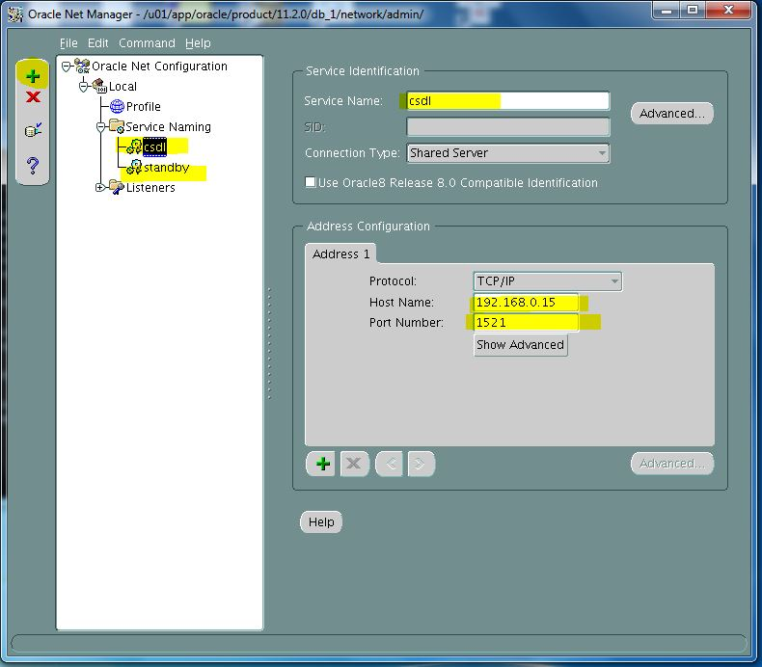

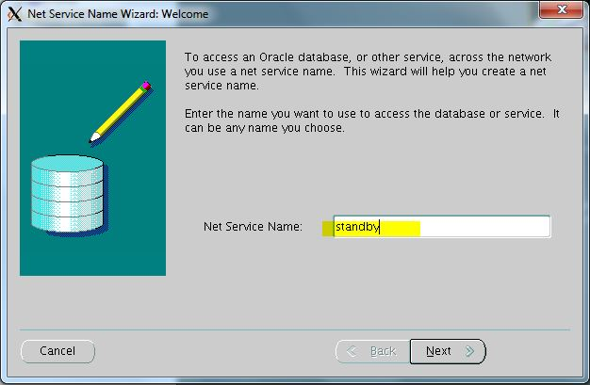

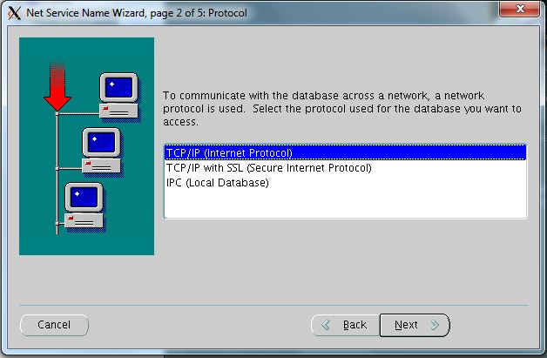

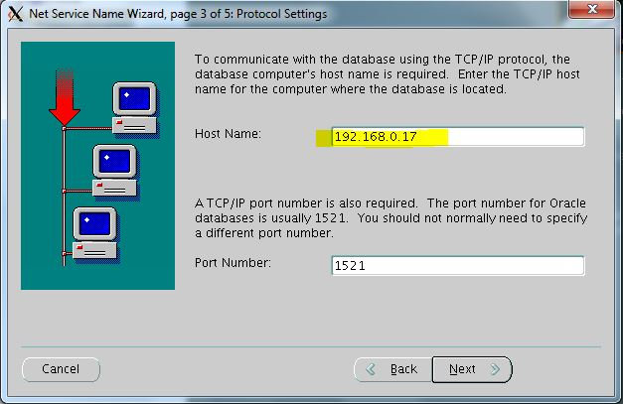

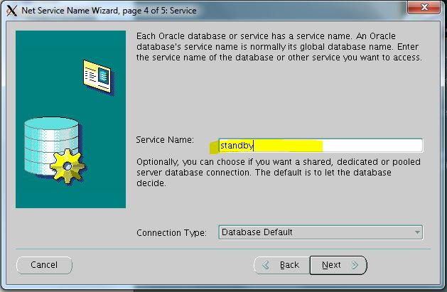

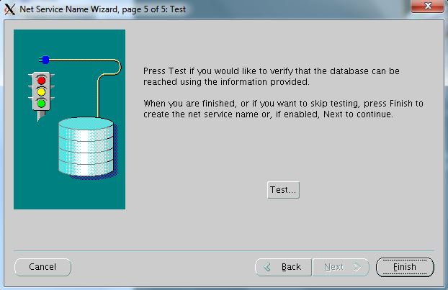

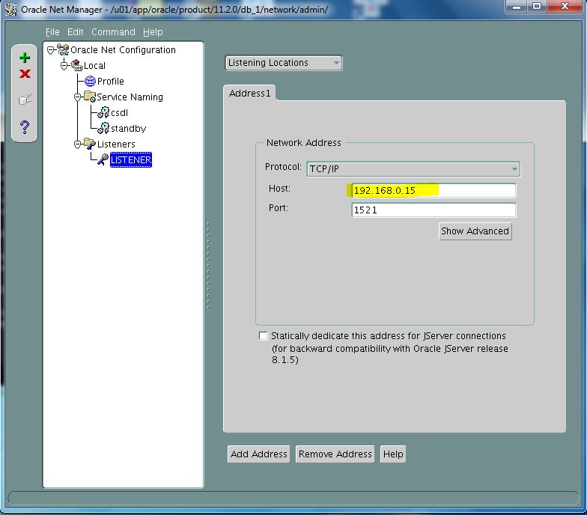

Test: lsnrctl start;

**Restart db**

|  |
| --- |
| SQL> shutdown immediate;  SQL> startup; |

**Tạo Pfile để chuyển sang máy standby**

|  |
| --- |
| SQL> create pfile=’đường dẫn’ from spfile; |
| Chỉnh sửa file initcsdl.ora đã được tạo. Chuyển các thông số theo quy chuẩn của máy standby sau đó copy sang máy standby 🡺tạo spfile cho standby   1. Change db_unique_name 2. Change fal_server 3. Change log_archive_dest_n 4. Change location of controlfile |

1. **Trên Standby**

**Cài đặt Database Oracle và netca ( không tạo dbca để đồng bộ sau từ Primary)**

**Backup database từ primary sang standby**

+ thu muc chua datafile

+ thu muc diag

+ thu muc admin

+ thu muc chua redo log, archive log

+ orapw file (orapwcsdl trong dbs)

Trên máy standby tạo các folder tương ứng như trong file pfile (initcsdl.ora) và các folder tương ứng

|  |
| --- |
| mkdir -p /u01/app/oracle/oradata/csdl  mkdir -p /u01/app/oracle/diag  mkdir -p /u01/app/oracle/admin/csdl  mkdir -p /redo1  mkdir -p /redo2  mkdir -p /archive_log  chown -R oracle:oinstall /u01/app/oracle/oradata/csdl  chown -R oracle:oinstall /u01/app/oracle/diag  chown -R oracle:oinstall /u01/app/oracle/admin/csdl  chown -R oracle:oinstall /redo01  chown -R oracle:oinstall /redo02  chown -R oracle:oinstall /archive_log |

Copy toàn bộ dữ liệu tại các folder này từ primzary sang standby.

**Tao controlfile cho máy STANDBY**

|  |
| --- |
| **Trên máy primary**  SQL>shutdown immediate;  SQL>startup;  SQL>alter database create standby controlfile as '/u01/app/oracle/oradata/csdl/controlstb01.ctl';  ( tao 2 controlfile)  cp /u01/app/oracle/oradata/csdl/control01.ctl /u01/app/oracle/oradata/csdl/controlstb02.ctl |

Copy control file sang thư mục đã cấu hình trong pfile

**Cấu hình spfile từ pfile đã cop sang (initcsdl.ora)**

|  |
| --- |
| SQL> shutdown;  SQL>create spfile from file=’đường dẫn’  SQL>startup nomount; |

**Sử dụng netmgr cấu hình Service Naming (như trên)**

Start listener trên cả hai server

$lsnrctl stop

$lsnrctl start

Kiểm tra giao tiếp giữa primary và standby sử dụng tnsping

$tnsping csdl (standby)

1. **Trên cả 2 server**

**Tạo standby redo log files**

|  |
| --- |
| SQL> startup mount  SQL> alter database add standby logfile '/redo01/stb_redo01_1.log' size 1000M;  SQL> alter database add standby logfile '/redo01/stb_redo02_1.log' size 1000M;  SQL> alter database add standby logfile '/redo02/stb_redo01_2.log' size 1000M;  SQL> alter database add standby logfile '/redo02/stb_redo02_2.log' size 1000M;  select member from v$logfile where type='STANDBY'; |

1. **Trên standby**

**Cấu hình Redo Apply cho Standby**

SQL> ALTER DATABASE RECOVER MANAGED STANDBY DATABASE DISCONNECT FROM SESSION;

|  |
| --- |
| Neu gap loi:  ERROR at line 1:  ORA-01665: control file is not a standby control file  thi thuc hien cac lenh sau:  SELECT database_role FROM v$database;  ALTER DATABASE CONVERT TO PHYSICAL STANDBY;  shutdown immediate;  STARTUP MOUNT;  alter database recover managed standby database disconnect from session; |

**Dừng tiến trình Redo Apply**

ALTER DATABASE RECOVER MANAGED STANDBY DATABASE CANCEL;

**Chuyển standby về chế độ Read-Only**

SQL>alter database recover managed standby database cancel;

SQL>alter database open read only;

Restart the Redo apply

SQL> recover managed standby database disconnect using current logfile;

**Test log transport**

**On the primary server, check the lastest archived redo log and force a log switch**

alter session set nls_date_format = 'dd.mm.yyyy hh24:mi:ss';

SELECT sequence#, first_time,next_time, applied FROM v$archived_log ORDER BY sequence#;

Archive log list;

ALTER SYSTEM SWITCH LOGFILE;

**Khi khong vao duoc web vi chua bat dbconsole su dung cau lenh**

[oracle@db1 dbs]$ emctl start dbconsole

Oracle Enterprise Manager 11g Database Control Release 11.2.0.1.0

Copyright (c) 1996, 2009 Oracle Corporation. All rights reserved.

https://db1:1158/em/console/aboutApplication

Starting Oracle Enterprise Manager 11g Database Control ................................... started.

------------------------------------------------------------------

Logs are generated in directory /u01/app/oracle/product/11.2.0/db_1/db1_csdl/sysman/log